|  |  |
| --- | --- |
| NAME | Jeevanandham S |
| TEAM ID | PNT2022TMID25961 |
| Project | Real-Time River Water Quality Monitoring and Control System |

Assignment -4

Question: Write code and connections in wokwi for ultrasonic sensor. Whenever distance is less than 100 cms send "alert" to ibm cloud and display in device recent events. Upload document with wokwi share link and images of ibm cloud

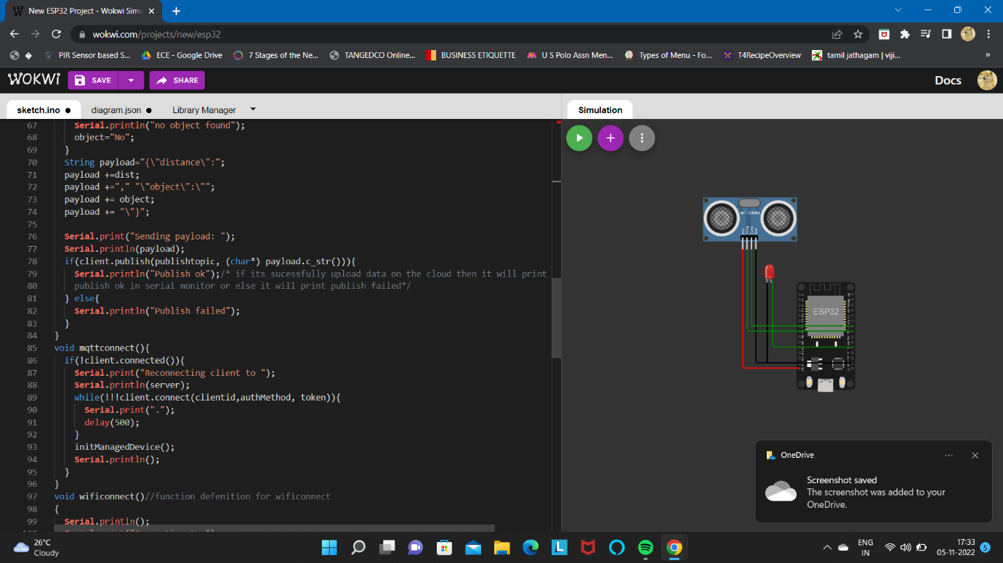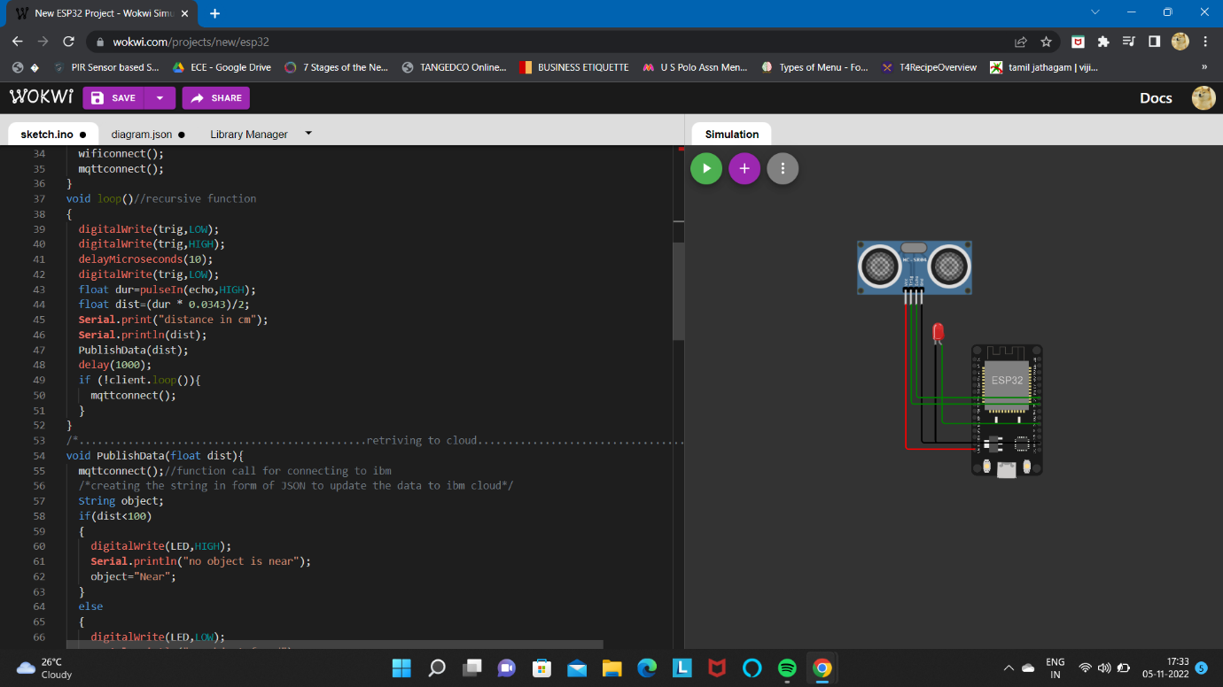

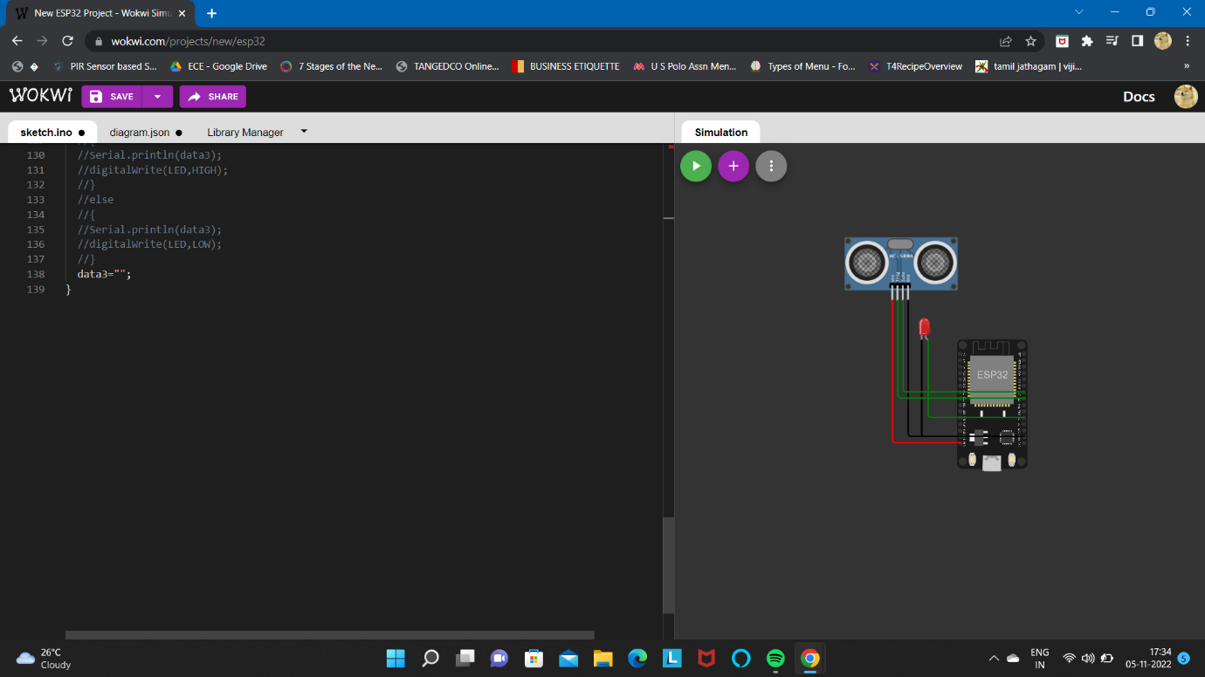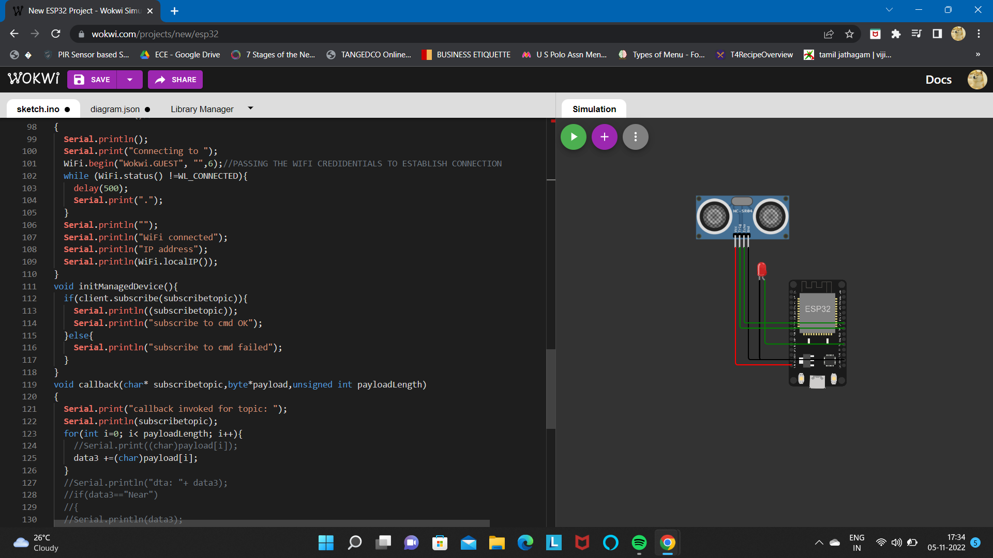

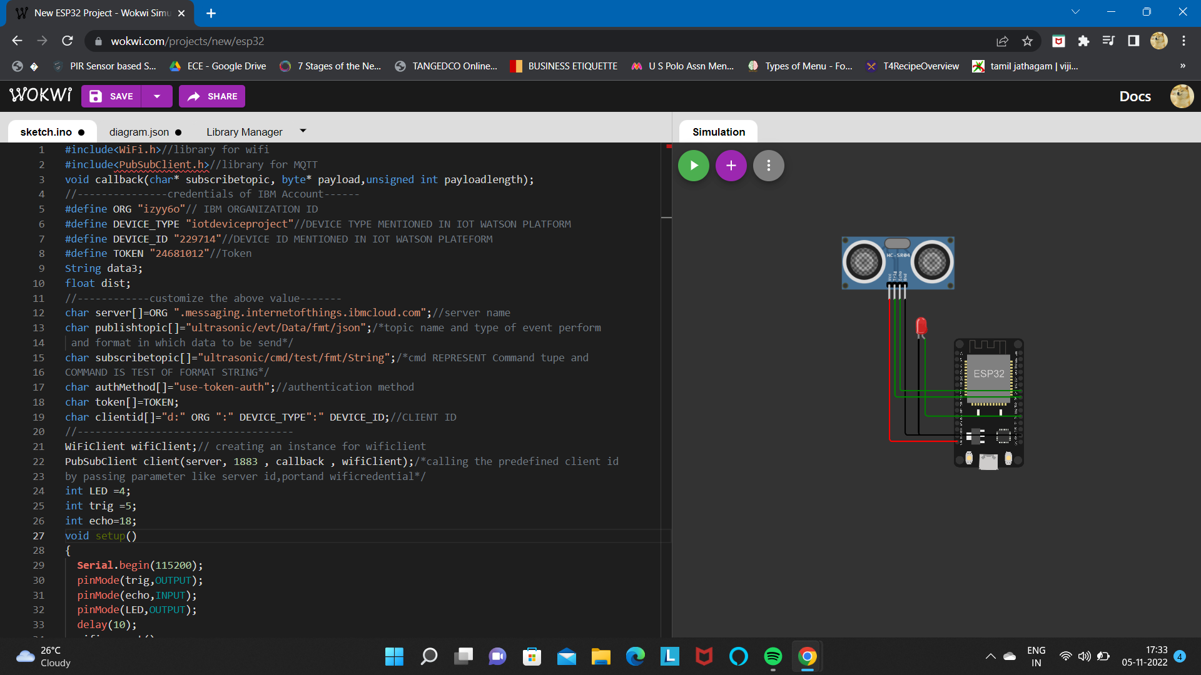

<https://wokwi.com/projects/347489586971148882>

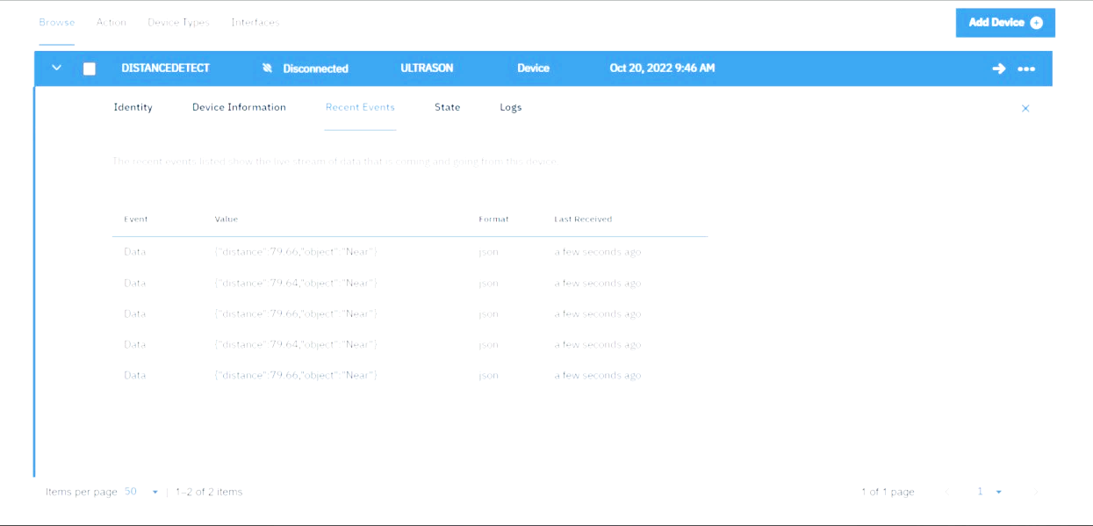

Data sent to the IBM Cloud Device when the object is near

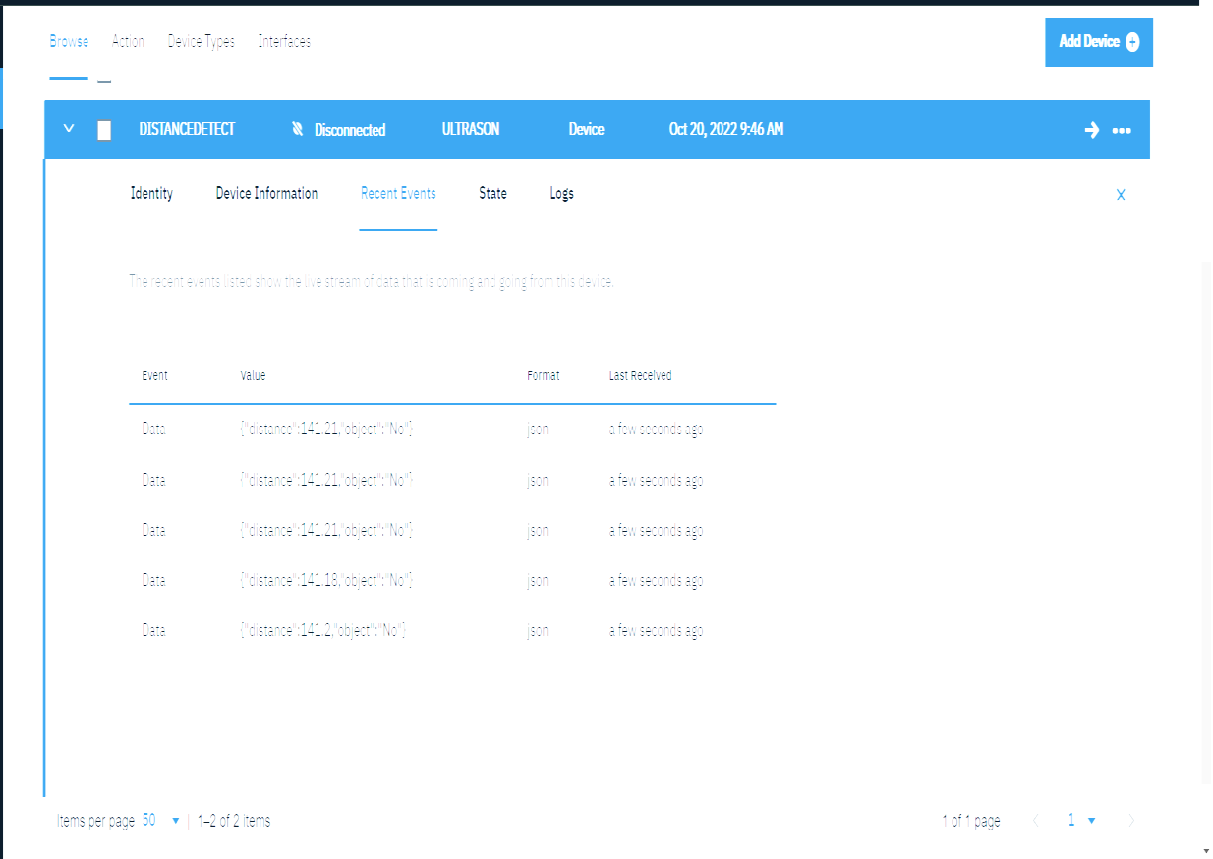

Data sent to the IBM Cloud Device when the object is far.